Multiscale Modeling and Testing of Protein-Bound Regolith and Soils
Downloaded from ascelibrary.org by University of Liverpool on 07/22/25. Copyright ASCE. For personal use only; all rights reserved.
I. Rosa¹; M. D. Lepech²; and D. J. Loftus³
¹Dept. of Civil and Environmental Engineering, Stanford Univ., Stanford, CA 94305, USA. E-mail: isamar@stanford.edu
²Dept. of Civil and Environmental Engineering, Stanford Univ., Stanford, CA 94305, USA. ³Space Bioscience Research Division, NASA Ames Research Center, Mountain View, CA 94305, USA.

ABSTRACT
Extraterrestrial construction presents many interesting and new challenges. Unlike Earth, there are very limited naturally occurring resources readily available in extraterrestrial environments, such as the Moon or Mars. Transporting large amounts of materials from Earth is cost prohibitive. Thus, this work focuses on a novel class of composites for use in limited resource environments: protein-bound soils. For space applications, the term regolith is used to refer to the loose soil-like material on the Moon, asteroids, and other planetary bodies. The composite is produced by mixing soil, water, and a biopolymer binder (protein or other biopolymer) to create a versatile composite with compressive strength comparable to that of ordinary Portland cement concrete. This paper proposes a multi-scale framework to model the composite’s fracture properties in order to design a durable material that can resist extreme environments. At the nanoscale, nanoindentation is used to obtain the mechanical properties of the dry protein after dissolving in water and desiccating. At the microscale, the creation of statistically equivalent periodic unit cells captures the interactions between soil particles, protein, and voids. Virtual tests are then used to obtain basic mechanical parameters. At the mesoscale, a rigid body spring model (RBSM) is used to simulate fracture using the homogenized properties obtained at the microscale. At the macroscale, triaxial testing and digital image correlation tests are used to corroborate and modify the simulations. The final goal of this project is to have a robust computational simulation that can enable the prediction of the mechanical properties of the protein-bound regolith material to be used to design future structures on the Moon, Mars, or other celestial bodies.

INTRODUCTION
One of the most challenging aspects of space surface operations is providing protection to both equipment and personnel after landing at extraterrestrial destinations. Without a strong magnetic field or a protective gaseous atmosphere, radiation exposure and the risk of meteorite impacts on extraterrestrial surfaces is a significant hurdle to advance exploration. In 2015, NASA announced its Journey to Mars Roadmap, and in it, described how in situ resource utilization was key to reduce the cost of space exploration and provide key infrastructure for successful missions (NASA 2015). Regolith, abundant on both the Moon and Mars, has the potential of providing the raw materials needed to build protective structures against radiation (Miller et al. 2009; Simonsen 1991). Protein-bound regolith could provide a low-energy, in situ construction material that can provide this protective infrastructure as well as soil stabilization for roads and landing pads (Figure 1).

Downloaded from ascelibrary.org by University of Liverpool on 07/22/25. Copyright ASCE. For personal use only; all rights reserved.
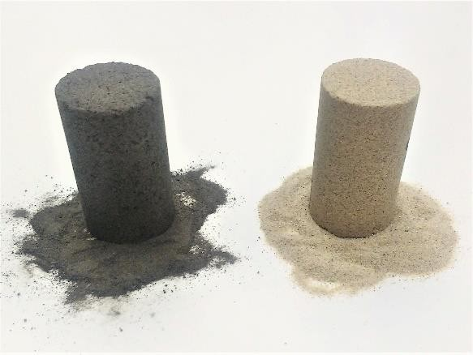

Figure 1. Protein bound soil cylinders made with Lunar Regolith Simulant (Left) and Graded Sand (Right). The cylinders have a diameter of 25.4 mm and a height of 50.4 mm.
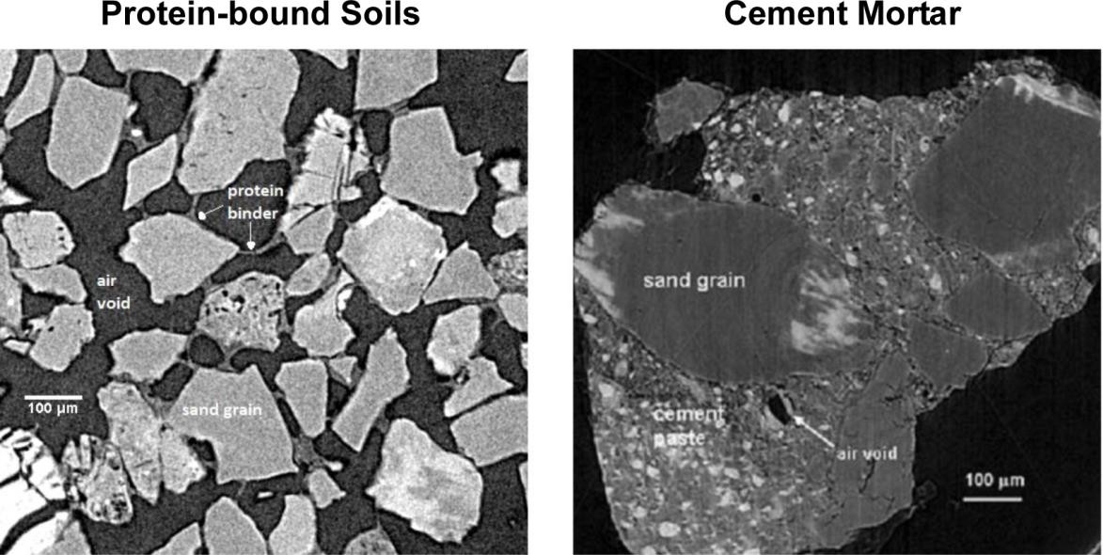

Figure 2. Comparison of the microstructure of protein-bound soils with cement mortar. On the left, a representative 2D slice of a 3D MicroCT image of protein-bound sand taken at a voxel resolution of 1.76 µm. On the right, a representative 2D slice of a 3D MicroCT image of Portland cement mortar taken at a resolution of 1.2 µm (Diamond and Landis 2007).
Images have been modified so that they are displayed at the same scale.
Current approaches for providing radiation shielding or impact protection require the transport of structures constructed on Earth, resulting in high launch costs, or the use of energy intensive methods in situ to sinter, bind or stabilize extraterrestrial soils (Roedel et al. 2014). To overcome these challenges, we have examined the concept of solidifying soil with a biopolymer binder to create a versatile construction composite. The protein-bound soil composite can be produced by mixing soil, water, and protein binder in situ, then removing water by evaporation or freeze drying. On the Moon, water needed for manufacture of the composite could be mined from shadowed craters where the water ice content is estimated to be 5.6% by mass (Colaprete et al. 2010). On Mars, recent evidence indicates abundant water ice and points to the possibility of liquid water, which could be harvested (Ojha et al. 2015). The binding proteins (or other biopolymers), which comprise less than 13% of the total composite mass, could either be produced on Earth and launched in small amounts to begin construction, or produced

extraterrestrially by engineered microorganisms that are grown locally (Cumbers and Rothchild 2010). Earlier studies from our research have shown that bovine-derived biological polymers (bovine serum albumin) are capable of binding regolith simulant, resulting in materials with ultimate compressive strengths similar to ordinary Portland cement concrete (Roedel et al. 2015).
Downloaded from ascelibrary.org by University of Liverpool on 07/22/25. Copyright ASCE. For personal use only; all rights reserved.
Although protein-bound soils are usually compared to concrete and cement mortar, there are significant differences at the microstructure level that prevent using multiscale models developed for cement and concrete materials to predict the macroscale mechanical behavior of protein-bound soils (Figure 2). Key amongst them is the higher porosity and the more compliant binder of the material. The porosity of protein bound soils has a range of 20-40%, and preliminary results hint that increase in porosity decreases compressive strength and fracture toughness. In ordinary Portland cement concrete and mortar, porosity ranges from 7-20% and multiple researchers have shown that higher porosity results in both reduced strength and durability (Hoff 1972; Kumar and Bhattacharjee 2003; Yaman et al. 2002). The binder in protein-bound soils is a viscoelastic, desiccated protein at a weight percentage of 5-15%. Studies focused on the mechanical properties of desiccated proteins are few, and preliminary results with
nanoindentation estimate a Young’s modulus of approximately 4 MPa (Berchane et al. 2008;
Brownsey et al. 2003; Perticaroli et al. 2013). The binder in concrete, hydrated Portland cement
paste, has a Young’s Modulus that ranges from 10-25 MPa and a weight percentage of up to 25% in the final mix (Akroyd 1962; Bye et al. 2011).
This paper describes the development of a multiscale framework for computational modeling of protein-bound regolith and soil composites. The framework incorporates a micromechanical model that uses the geometric configuration of the constituents and captures binder connections and overall porosity in protein-bound soils. The framework also adopts a mesoscale model that captures the fracture response of the material. Both of these are essential for unraveling the relationship between the microstructure and mechanical properties. Ultimately, this framework will include experimental nanoindentation measurements of the elastic response of the protein binder, and the uniaxial and triaxial mechanical response of the bulk material. A detailed description of the framework is discussed and avenues for future work are presented.

DEVELOPMENT OF A MULTISCALE FRAMEWORK
Every heterogeneous composite has unique constituents, geometric configurations and length scales that merit tailored multiscale frameworks when studying them. In addition, investigators use different numerical and experimental techniques to study a material’s properties at various length scales, which can result in a myriad of frameworks for the same material. Multiscale frameworks have been used to understand electrical, thermal, chemical or mechanical properties of materials and also the coupling between these properties (Kanouté et al. 2009; Torquato 2002). Scales can range from the atomic scale to the building scale. The power of multiscale frameworks for understanding heterogeneous material lies in the simple equations that are used to describe the different phases. The coupling of these can give insights and predictions of the system’s behavior as a whole. Using the effective material properties obtained at the heterogeneous microscale in a macroscale model is numerically efficient and has been used to successfully model both linear and non-linear material responses (Šejnoha and Zeman 2013).
Adopting concrete as an example, there exist a multitude of successful mechanical models that attempt to understand the nature of concrete materials by coupling cement paste microscale models, aggregate interface mesoscale models, and macroscale homogenized structural models (Maekawa et al. 2003; Nguyen et al. 2012; Ulm et al. 2004; Unger and Eckardt 2011; Vorel et al.

2012). The inputs for these models can be from both experiments at the macroscale or at the nanoscale. Nanoindentention has proven especially useful to obtain the mechanical properties of individual components of the cement paste and interfacial zone (Constantinides et al. 2003).
Downloaded from ascelibrary.org by University of Liverpool on 07/22/25. Copyright ASCE. For personal use only; all rights reserved.
In creating a multiscale framework for protein-bound soils, the microstructure was the central focus of the modeling. At a resolution of approximately 1 µm, protein features, soil particles and void spaces can be clearly observed and the heterogeneity of the material becomes apparent. In protein-bound soils the protein coats the soil particles and also form bridges that connect adjacent soil particles. Although in 2D images, these bridges appear to be filaments (Figure 2), 3D images show that the bridges may actually be like thin films bridges (Figure 3). To capture the details and variation at this length scale, a Statistically Equivalent Periodic Unit Cell, proposed by Sejnoha and Zeman, was employed as the representative volume element for the micromechanical modeling (Rosa et al. 2016; Šejnoha and Zeman 2013). To complete the micromechanical modeling, information about the behavior of the protein is essential.
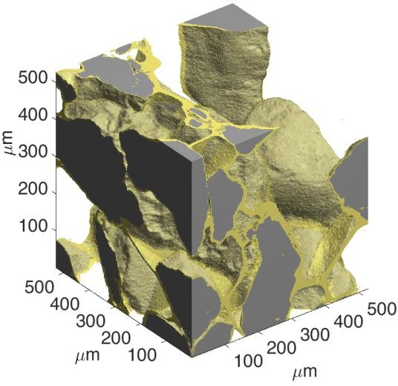

Figure 3. Close-up of the microstructure of protein-bound soils. Notice the shape of the protein film bridges that join the particles together.
The multiscale modeling and testing framework for protein-bound soils which is presented in this paper aims to create a methodological foundation for deeper study of this novel class of materials. Future research venues include examination of the suitability of different proteins and soils. Thus, having a library of tests that quantifies key properties of the constituents, together with numerical models from which the properties of the resulting materials can be predicted, will allow exploration of wide range of material variants and a faster design process. In addition, understanding of this class of materials in a multiscale context can highlight areas for further study and give insights as to which modeling and experimental techniques can be useful. Future work in understanding the interface between protein and soil might involve nanoscale testing, Scanning Electron Microscopy imaging, modeling at the nanoscale, and further mechanical testing at the mesoscale or macroscale. For the purpose of this paper, we define the proposed multiscale experimental and modeling framework in Figure 4. At the smallest scale, nanoindentation results are used to investigate protein mechanics. At the microscale, the heterogeneous structure is modeled using Statistically Equivalent Periodic Unit Cells created with data obtained from MicroCT scans (Rosa et al. 2016; Šejnoha and Zeman 2013). This data is then used in a mesoscale Rigid Body Spring Model to simulate fracture in the homogenized material and predict its strength (Nagai et al. 2005). Finally, triaxial tests at the macroscale are

used to better understand the failure yield surface and uniaxial tests coupled with digital image correlation are used to study the fracture behavior and other macroscale properties. Each of these four scales of the framework is discussed in further detail in the following sub-sections.
Downloaded from ascelibrary.org by University of Liverpool on 07/22/25. Copyright ASCE. For personal use only; all rights reserved.
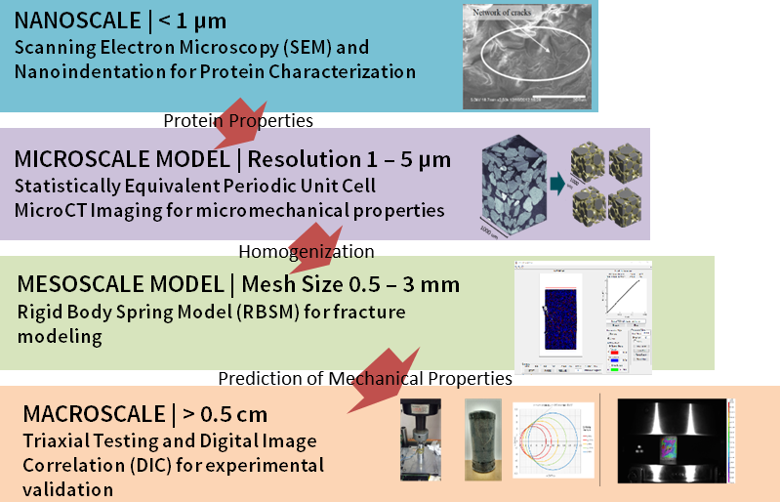

Figure 4. Visualization of the framework for multiscale modeling and testing of protein-bound soils.
- Nanoscale: Nanoindentation for Mechanical Response of Desiccated Protein
Nanoindentation is a powerful technique that has been used with much success to understand the mechanical properties of both biological and cementitious materials (Constantinides et al.
2003; Haque 2003; Velez et al. 2001; Xiao et al. 2013). Nanoindentation provides the ability to test for a material’s constituent’s individual hardness and elastic properties in-situ or using very small sample sizes. This is of particular interest to this project since creating a pure protein sample large enough for typical, full-scale mechanical test methods (i.e. uniaxial tension coupons) is unfeasible. In addition, if nanoindentation tests are coupled with nanoscales simulations, post yield behavior assumptions can be tested and the plasticity equation coefficients be fitted to the data (Mullins et al. 2009; Rajagopalan and Vaidyanathan 2002).
Preliminary nanoindentation tests have proven the feasibility of obtaining the linear elastic properties of dried protein. Further work is needed to corroborate these results and to explore the viscoelastic and plastic properties of dried proteins using nanoindentation.

Microscale: MicroCT Imaging and Micromechanical Modeling
Microscale computational models can reduce the number of time consuming laboratory experiments and measurements needed to understand the behavior of new and existing heterogeneous materials (NIST 2013; Šejnoha et al. 2004; Šejnoha and Zeman 2013). The model’s accuracy in predicting a material’s behavior depends on the model’s ability to capture the statistical nature of the random heterogeneous material (Torquato 2002). To begin this analysis, virtual 3-D representative volume elements were created that capture the geometric

arrangement of soil particles, protein features and void spaces in the material. These virtual 3-D representations statistically match the observed material microstructure obtained through micro-computed tomography (MicroCT), since they were created utilizing the Statistically Equivalent Periodic Unit Cell method described by Šejnoha and Zeman (Rosa et al. 2016).
Downloaded from ascelibrary.org by University of Liverpool on 07/22/25. Copyright ASCE. For personal use only; all rights reserved.
A summary of the framework at the microscale is presented in Figure 5. The method first requires the creation of periodic unit cells with particles and protein features. Data from MicroCT scans is used to create ellipsoidal approximations of soil particles, and also used as the source of the geometrical statistical descriptors that form the basis of the Statistically Equivalent Periodic Unit Cells (SEPUC) method. A genetic algorithm is then used to minimize the differences between the descriptors, comparing the periodic unit cells to the real images. After several generations, this method creates a population of SEPUC’s that can be used for numerical simulations (Rosa et al. 2016). From the numerical simulations, which take as input the component mechanical properties, particularly of the protein phase, one can obtain the bulk
material properties, particularly the homogenized Young’s modulus Ehom and Poisson’s ratio
vhom .
Future work will concentrate on implementing a numerical model, be it a version that uses Finite Elements (FEM or X-FEM), Discrete Element (DEM) or peridynamics, to obtain the homogenized mechanical properties from the heterogeneous representation of the microstructure, as others have done successfully for multiple materials (Askari et al. 2008; You et al. 2009; Zeman and Šejnoha 2004).
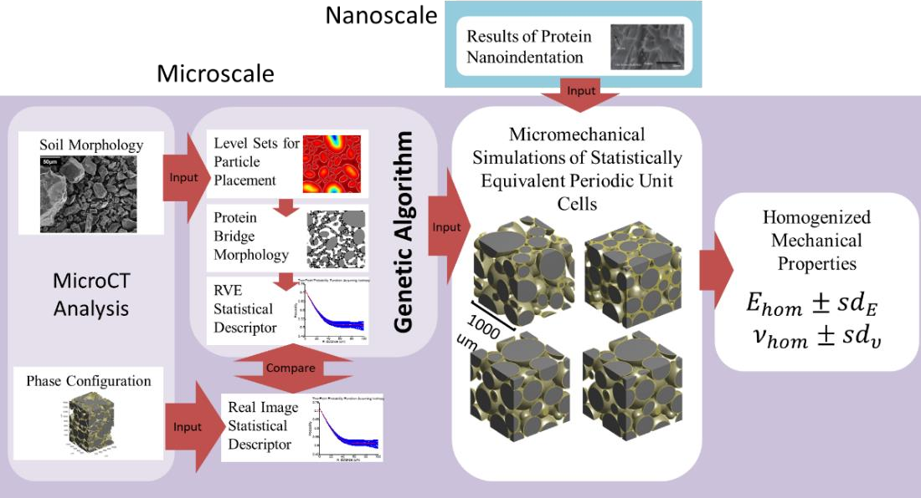

Figure 5. Flowchart of the microscale framework for numerical modeling of protein-bound soils based on the work by Sejnoha and Zeman (2013).
- Mesoscale: Modeling of Crack Propagation in Homogenized Material
Mesoscale models, when there is good correspondence with experimental results, can give powerful insights into how cracks propagate within a homogenized material and their effects on ultimate strength. Although many models for crack simulations exist, the one implemented in this multiscale framework is a lattice model known as the Rigid Body Spring Method (RBSM). The method was developed by T. Kawai and used extensively to model fracture behavior in

concrete and cement mortar (Bolander and Saito 1998; Kawai 1978; Nagai et al. 2005; Ueda et al. 2009). RBSM offers a model that is conceptually simple, low-biased towards crack orientations and robust in non-linear analysis. Efforts are underway to adapt the model to protein-bound soils. In comparing cement mortar to protein-bound soils, differences in the microstructure and fundamental components translate into different responses in the bulk mechanical behavior, with stiffness being chief among them. Cement mortar has a stiffness of approximately 22 GPa and a compressive strength of approximately 35 MPa. Conversely, protein-bound regolith has a stiffness of approximately 1.2 GPa and a compressive strength of approximately 12 MPa. Thus, at failure, protein-bound soils exhibit larger deformations, which
Downloaded from ascelibrary.org by University of Liverpool on 07/22/25. Copyright ASCE. For personal use only; all rights reserved.
must be carefully considered when applying a mechanical model. Additional challenges lie in the formulation of the plasticity and yield assumptions which are critical for the successful modeling of the non-linear behavior of the material.
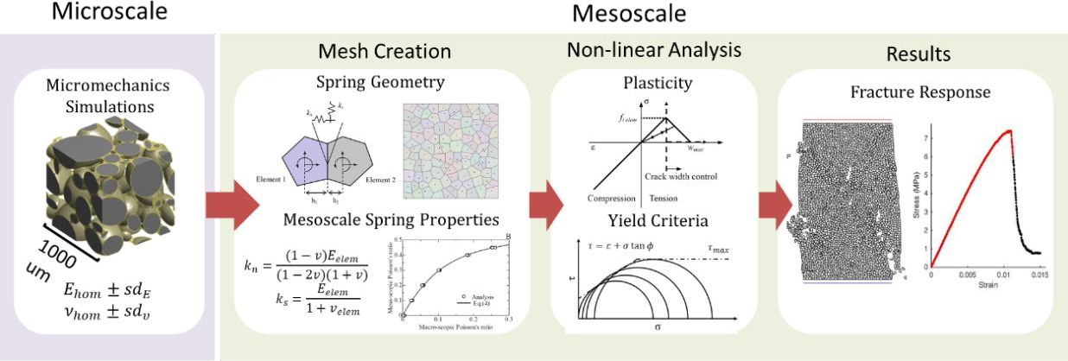

Figure 6. Flowchart of the mesoscale model for protein-bound soils based on the Rigid Body Spring Model for mortars by Nagai et. al (2004).
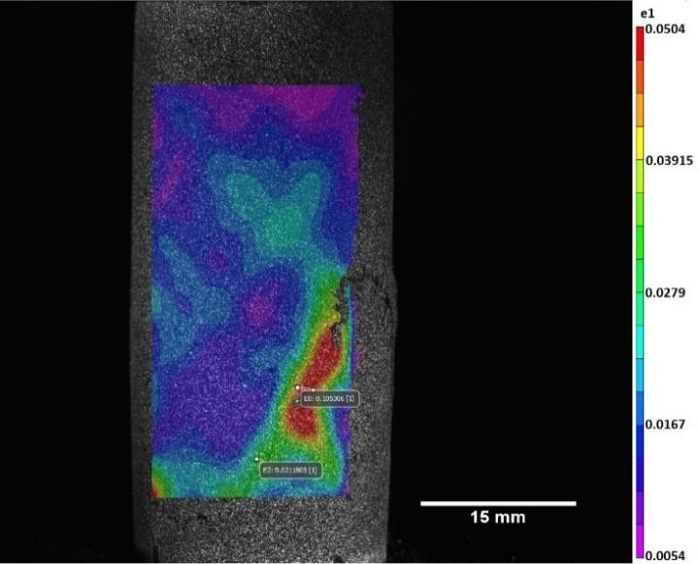

Figure 7. Preliminary results from a compression test of protein-bound regolith recorded using Digital Image Correlation equipment and software provided by Correlated Solutions Inc. (Colombia, SC, USA). The capability of placing digital extensometers a posteriori is particularly useful for studying crack initiation (Schreier et al. 2009). The colormap corresponds to the primary component of the Lagrangian stress tensor, e₁ .
The framework, detailed in Figure 6, is currently being developed while keeping larger

deformations and differing yield behavior of protein-bound soils in mind. Following the method detailed by Nagai’s paper, the mean and standard deviation of the homogenized mechanical properties from the microscale are used to assign the mesoscale properties of a spring network. This spring network is created using random Voronoi diagrams. Then, the non-linear behavior of the network then is analyzed based on plasticity and yield criteria assumptions for the material.
Downloaded from ascelibrary.org by University of Liverpool on 07/22/25. Copyright ASCE. For personal use only; all rights reserved.
Finally, from this analysis, the expected crack pattern and maximum strength are obtained.

Macroscale: Triaxial and Uniaxial Testing for Mechanical Properties
Finally, at the macroscale, experimental testing can provide validation of the numerical models and further insight into the material’s overall behavior. In this framework, two experimental techniques are included: uniaxial tests, aided by 3-D digital image correlation (3D DIC); and triaxial tests. Uniaxial tests are underway to determine the strength in both uniaxial compression and uniaxial tension as a function of mix design. In addition, 3D DIC is powerful tool that can be used to understand strain development, crack initiation and Poisson’s ratio, parameters that are just starting to be characterized in protein-bound soils (Roux et al. 2009; Schreier et al. 2009). Preliminary 3D DIC data is shown in Figure 7.
Triaxial tests, used extensively in rock mechanics, are essential to understanding the yield and plastic behavior of brittle and quasi-brittle bulk materials (Fujii et al. 1999; Klerck et al. 2004; Shao et al. 2006). The Mohr-Coulomb criteria is a linear approximation of the yield surface shear stress, τ , using the normal compressive stress, σ , and two material constants, the internal friction angle, ϕ , and material cohesion, c.
τ = c +σ tanϕ
This relationship can be calculated from triaxial tests at various confining pressures and can be used as input in the RBSM model, or as validation for RBSM simulations (Bolander and Saito 1998; Kawai 1991). Preliminary studies for protein-bound soils hint that this relationship is linear up to certain confining pressures, thus permitting the approximation with the Mohr-Coloumb criteria. Nevertheless, additional studies are needed to fully characterize this hypothesis.

CONCLUSIONS & FUTURE WORK
This paper presents the developing framework for a multi-scale understanding of protein-bound soils. The framework’s primary engine is micromechanics modeling and microscale
imaging to capture the material’s heterogeneity. This is aided by nanoindentation tests to understand the mechanical behavior of dry proteins. The results at the microscale are then implemented in a mesoscale model to simulate fracture properties and crack development. Finally, results are validated by macroscale tests of the bulk material. This multiscale approach has the potential to accelerate the development of protein-bound soil composites and can serve as a guiding force for tailoring mix designs for varying environments and load requirements, resulting in faster implementation for real-world applications.
At the moment, parallel efforts are underway in performing nanoindentation and uniaxial experiments, creating and modifying the microscale and mesoscale computational models, and analyzing and cataloging the data of previous macroscale experiments. The goal is to synthesize both the computational simulations and material experiments in order to yield insights into how the mix components and their proportions affect the composite’s mechanical properties. In addition, once the computational simulations have been validated, these can be used to optimize

the mix design according to user-defined objectives. In the future, we envision extending the framework to include the system scale, to extrapolate beyond our understanding of the material to an understanding of how full scale extraterrestrial structures will behave.
Downloaded from ascelibrary.org by University of Liverpool on 07/22/25. Copyright ASCE. For personal use only; all rights reserved.

ACKNOWLEDGMENTS
This material is based upon work supported by the National Science Foundation Graduate Research Fellowship under Grant No. DGE-114747 and by the Stanford Graduate Fellowship under the donation of William R. and Sara Hart Kimball. In addition, work done in Japan under the guidance of Prof. Tamon Ueda at the Laboratory for System Maintenance and Prof. Yoshiaki Fujii at the Rock Mechanics Laboratory of Hokkaido University was funded under the National Science Foundation East Asia and Pacific Summer Institute Fellowship No. OISE-1614201 and the Japan Society for the Promotion of Science. The bulk of the work was done at the John A. Blume Earthquake Engineering Center at Stanford University. The MicroCT images were obtained at the Material Measurement Laboratory of the National Institute of Standards and Technology in Boulder, Colorado thanks to Dr. Edward Garboczi. The authors also gratefully acknowledge funding support from the NASA Ames Research Center; the Game Changing Development Program, Science and Technology Mission Directorate, NASA; the Division of Space Biosciences at NASA Ames Research Center; and the Department of Civil and Environmental Engineering, Stanford University. Any opinions, findings, and conclusions or recommendations expressed in this material are those of the authors and do not necessarily reflect the views of the United States National Science Foundation.

REFERENCES
Akroyd, T. N. W. (1962). “CHAPTER 3 - MIX DESIGN.” Concrete, Pergamon, 121–168.
Askari, E., Bobaru, F., Lehoucq, R. B., Parks, M. L., Silling, S. A., and Weckner, O. (2008). “Peridynamics for multiscale materials modeling.” Journal of Physics: Conference Series, 125(1), 012078.
Berchane, N. S., Andrews, M. J., Kerr, S., Slater, N. K. H., and Jebrail, F. F. (2008). “On the mechanical properties of bovine serum albumin (BSA) adhesives.” Journal of Materials Science: Materials in Medicine, 19(4), 1831–1838.
Bolander, J. E., and Saito, S. (1998). “Fracture analyses using spring networks with random geometry.” Engineering Fracture Mechanics, 61(5), 569–591.
Brownsey, G. J., Noel, T. R., Parker, R., and Ring, S. G. (2003). “The Glass Transition Behavior of the Globular Protein Bovine Serum Albumin.” Biophysical Journal, 85(6), 3943–3950.
Bye, G., Livesey, P., and Struble, L. (2011). Portland Cement. ICE Publishing, London, UK. Colaprete, A., Schultz, P., Heldmann, J., Wooden, D., Shirley, M., Ennico, K., Hermalyn, B.,
Marshall, W., Ricco, A., Elphic, R. C., Goldstein, D., Summy, D., Bart, G. D., Asphaug, E., Korycansky, D., Landis, D., and Sollitt, L. (2010). “Detection of Water in the LCROSS Ejecta Plume.” Science, 330(6003), 463–468.
Constantinides, G., Ulm, F.-J., and Vliet, K. V. (2003). “On the use of nanoindentation for cementitious materials.” Materials and Structures, 36(3), 191–196.
Cumbers, J., and Rothchild, L. (2010). “BISRU: Synthetic Microbes for Moon, Mars and Beyond.” LPI Contributions, 1538, 5672.
Diamond, S., and Landis, E. (2007). “Microstructural features of a mortar as seen by computed microtomography.” Materials and Structures, 40(9), 989–993.
Fujii, Y., Ishijima, Y., and Kiyama, T. (1999). “Confining pressure-dependency of coefficients in

the simple constitutive equations for brittle rock.” Strain, 10, 2.
Downloaded from ascelibrary.org by University of Liverpool on 07/22/25. Copyright ASCE. For personal use only; all rights reserved.
Haque, F. (2003). “Application of Nanoindentation Development of Biomedical to Materials.” Surface Engineering, 19(4), 255–268.
Hoff, G. C. (1972). “Porosity-strength considerations for cellular concrete.” Cement and Concrete Research, 2(1), 91–100.
Kanouté, P., Boso, D. P., Chaboche, J. L., and Schrefler, B. A. (2009). “Multiscale Methods for Composites: A Review.” Archives of Computational Methods in Engineering, 16(1), 31–75.
Kawai, T. (1978). “New discrete models and their application to seismic response analysis of structures.” Nuclear Engineering and Design, Special Issue Structural Mechanics in Reactor Technology - Smirt-4, 48(1), 207–229.
Kawai, T. (1991). “Discrete Limit Analysis of Reinforced Concrete Structures Using Rigid Bodies-Spring Models.” Chapter in The finite element method in the 1990’s, E. Oñate, J. Periaux, and A. Samuelsson, eds., Springer Berlin, Heidelberg, 182–191.
Klerck, P. A., Sellers, E. J., and Owen, D. R. J. (2004). “Discrete fracture in quasi-brittle materials under compressive and tensile stress states.” Computer Methods in Applied Mechanics and Engineering, 193(27), 3035–3056.
Kumar, R., and Bhattacharjee, B. (2003). “Porosity, pore size distribution and in situ strength of concrete.” Cement and Concrete Research, 33(1), 155–164.
Maekawa, K., Ishida, T., and Kishi, T. (2003). “Multi-scale Modeling of Concrete Performance.” Journal of Advanced Concrete Technology, 1(2), 91–126.
Miller, J., Taylor, L., Zeitlin, C., Heilbronn, L., Guetersloh, S., DiGiuseppe, M., Iwata, Y., and Murakami, T. (2009). “Lunar soil as shielding against space radiation.” Radiation Measurements, 44(2), 163–167.
Mullins, L. P., Bruzzi, M. S., and McHugh, P. E. (2009). “Calibration of a constitutive model for the post-yield behaviour of cortical bone.” Journal of the Mechanical Behavior of Biomedical Materials, 2(5), 460–470.
Nagai, K., Sato, Y., and Ueda, T. (2005). “Mesoscopic simulation of failure of mortar and concrete by 3D RBSM.” Journal of Advanced Concrete Technology, 3(3), 385–402.
NASA. (2015). “Journey to Mars: Pioneering Next Steps in Space Eploration.” National Aeronautics and Space Administration, Washington, D.C.
Nguyen, V. P., Stroeven, M., and Sluys, L. J. (2012). “Multiscale failure modeling of concrete: Micromechanical modeling, discontinuous homogenization and parallel computations.” Computer Methods in Applied Mechanics and Engineering, 201–204, 139–156.
NIST. (2013). “Virtual Cement and Concrete Testing Laboratory.” National Institute for Standards and Testing, <http://concrete.nist.gov/> (Apr. 20, 2015).
Ojha, L., Wilhelm, M. B., Murchie, S. L., McEwen, A. S., Wray, J. J., Hanley, J., Massé, M., and Chojnacki, M. (2015). “Spectral evidence for hydrated salts in recurring slope lineae on Mars.” Nature Geoscience, 8(11), 829–832.
Perticaroli, S., Nickels, J. D., Ehlers, G., O’Neill, H., Zhang, Q., and Sokolov, A. P. (2013). “Secondary structure and rigidity in model proteins.” Soft Matter, 9(40), 9548–9556.
Rajagopalan, S., and Vaidyanathan, R. (2002). “Nano- and microscale mechanical characterization using instrumented indentation.” JOM, 54(9), 45–48.
Roedel, H., Lepech, M. D., and Loftus, D. J. (2014). “Protein-Regolith Composites for Space Construction.” Proceedings of the 14th ASCE International Conference on Engineering, Science, Construction and Operations in Challenging Environments, ASCE, Reston, VA.
Roedel, H., Rosa Plata, I., Lepech, M. D., and Loftus, D. J. (2015). “Sustainability Assessment

of Protein-Soil Composite Materials for Limited Resource Environments.” Journal of Renewable Materials, 3(3), 183-194.
Downloaded from ascelibrary.org by University of Liverpool on 07/22/25. Copyright ASCE. For personal use only; all rights reserved.
Rosa, I., Roedel, H., Lepech, M., Loftus, D., and Garboczi, E. (2016). “Three-Phase Statistically Equivalent Periodic Unit Cells for Protein-Bound Soils (Pre-Publication).” Proceedings of the 15th ASCE International Conference on Engineering, Science, Construction and Operations in Challenging Environments, ASCE, Reston, VA.
Roux, S., Réthoré, J., and Hild, F. (2009). “Digital image correlation and fracture: an advanced technique for estimating stress intensity factors of 2D and 3D cracks.” Journal of Physics D: Applied Physics, 42(21), 214004.
Schreier, H., Orteu, J.-J., and Sutton, M. A. (2009). Image Correlation for Shape, Motion and Deformation Measurements. Springer US, Boston, MA.
Šejnoha, M., Valenta, R., and Zeman, J. (2004). “Nonlinear viscoelastic analysis of statistically homogeneous random composites.” International Journal for Multiscale Computational Engineering, 2(4), 645–673.
Šejnoha, M., and Zeman, J. (2013). Micromechanics in Practice. WIT Press, Billerica, MA. Shao, J. F., Jia, Y., Kondo, D., and Chiarelli, A. S. (2006). “A coupled elastoplastic damage model for semi-brittle materials and extension to unsaturated conditions.” Mechanics of
Materials, 38(3), 218–232.
Simonsen, L. C. N. (1991). “Radiation protection for human missions to the Moon and Mars.” NASA/TP-1991-3079, National Aeronautics and Space Administration, Washington, D.C.
Torquato, S. (2002). Random Heterogeneous Materials. Springer, New York, NY.
Ueda, T., Hasan, M., Nagai, K., Sato, Y., and Wang, L. (2009). “Mesoscale simulation of influence of frost damage on mechanical properties of concrete.” Journal of Materials in Civil Engineering, 21(6), 244–252.
Ulm, F.-J., Constantinides, G., and Heukamp, F. H. (2004). “Is concrete a poromechanics materials? —A multiscale investigation of poroelastic properties.” Materials and Structures, 37(1), 43–58.
Unger, J. F., and Eckardt, S. (2011). “Multiscale Modeling of Concrete.” Archives of Computational Methods in Engineering, 18(3), 341.
Velez, K., Maximilien, S., Damidot, D., Fantozzi, G., and Sorrentino, F. (2001). “Determination by nanoindentation of elastic modulus and hardness of pure constituents of Portland cement clinker.” Cement and Concrete Research, 31(4), 555–561.
Vorel, J., Šmilauer, V., and Bittnar, Z. (2012). “Multiscale simulations of concrete mechanical tests.” Journal of Computational and Applied Mathematics, 236(18), 4882–4892.
Xiao, J., Li, W., Sun, Z., Lange, D. A., and Shah, S. P. (2013). “Properties of interfacial transition zones in recycled aggregate concrete tested by nanoindentation.” Cement and Concrete Composites, 37(Supplement C), 276–292.
Yaman, I. O., Aktan, H. M., and Hearn, N. (2002). “Active and non-active porosity in concrete Part II: Evaluation of existing models.” Materials and Structures, 35(2), 110.
You, Z., Adhikari, S., and Kutay, M. E. (2009). “Dynamic modulus simulation of the asphalt concrete using the X-ray computed tomography images.” Materials and Structures, 42(5), 617–630.
Zeman, J., and Šejnoha, M. (2004). “Homogenization of balanced plain weave composites with imperfect microstructure: Part I––Theoretical formulation.” International Journal of Solids and Structures, 41(22–23), 6549–6571.

